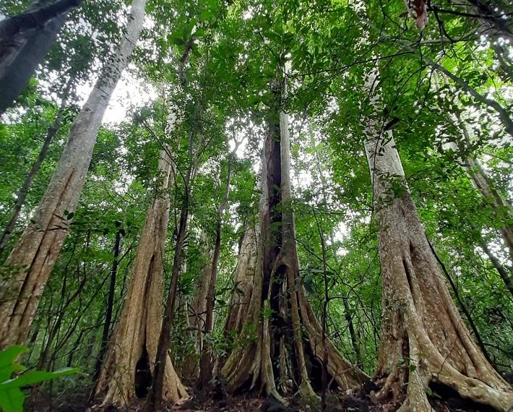

Towering tropical forest
Massive trunks, irregular branches, dense overlapping canopies, and deep shadows.

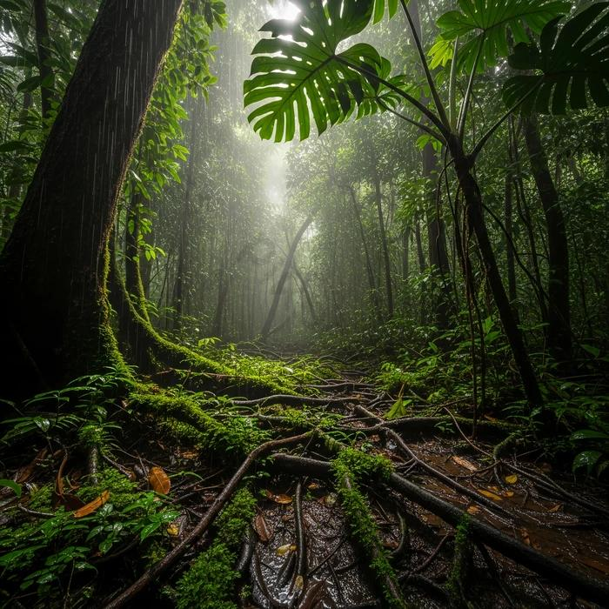

Organic terrain
Wet soil, exposed roots, moss, ferns, decaying leaves, and ground-level mist.

